SYSTEMS ANALYSIS AND MODELLING

2 - AMALIY ISH
MATLAB DA KO'PXADLAR

Bajardi: Bozorqulov Sardor
Guruh: ISEE-01U

1-Topshiriq: Ko'pxad Amallari
Berilgan:

p(s) = s² + 2s + 1

q(s) = s + 1

1a) p(s) × q(s) — Ko'paytirish
Ko'pxadlarni ko'paytirish uchun conv() funksiyasidan foydalanamiz:

clc
clear

p = [1 2 1]; % s^2 + 2s + 1
q = [1 1]; % s + 1

disp('p(s) * q(s) natijasi:')
kopaytma = conv(p, q)

Terminal Screenshot:
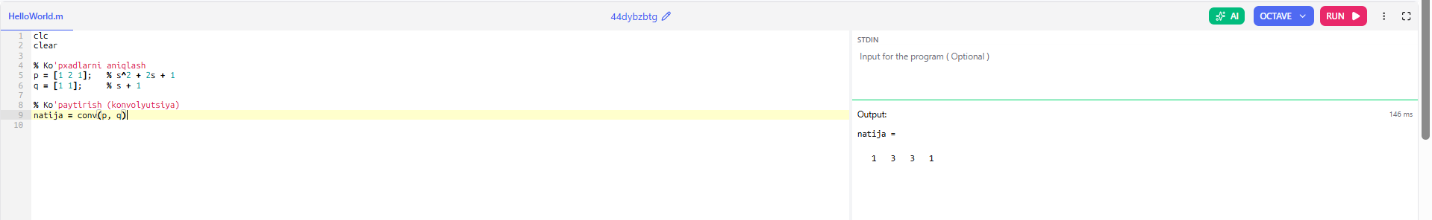

1b) p(s) va q(s) Ildizlari
roots() funksiyasi ko'pxadning ildizlarini hisoblaydi:

disp('p(s) ildizlari:')
roots_p = roots(p)

disp('q(s) ildizlari:')
roots_q = roots(q)

Terminal Screenshot:
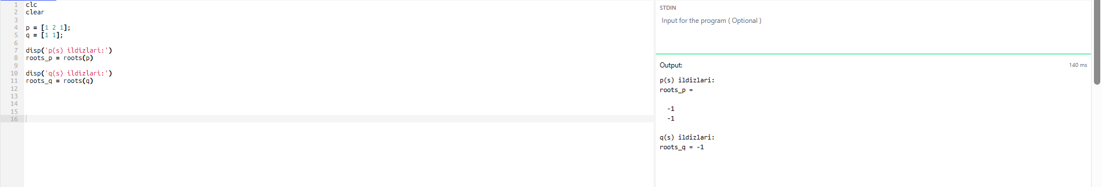

1c) p(-1) va q(6) Qiymatlarini Hisoblash
polyval() funksiyasi ko'pxadni berilgan nuqtada hisoblaydi:

disp('p(-1) qiymati:')
polyval(p, -1)

disp('q(6) qiymati:')
polyval(q, 6)

Terminal Screenshot:
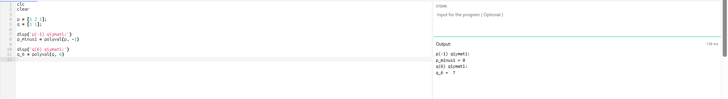

1-Topshiriq — To'liq Kod
clc
clear

p = [1 2 1]; % s^2 + 2s + 1
q = [1 1]; % s + 1

% 1a) Ko'paytirish
disp('=== 1a) p(s) * q(s) ===')
conv(p, q)

% 1b) Ildizlar
disp('=== 1b) Ildizlar ===')
disp('p(s) ildizlari:')
roots(p)
disp('q(s) ildizlari:')
roots(q)

% 1c) Qiymatlar
disp('=== 1c) Qiymatlar ===')
disp('p(-1):')
polyval(p, -1)
disp('q(6):')
polyval(q, 6)

2-Topshiriq: Qism Kasrga Yoyish (Partial Fraction)
residue() funksiyasi ikkita ko'pxad nisbatining qism kasr yoyilmasini topadi. Umumiy ko'rinish:

B(s)/A(s) = r1/(s-p1) + r2/(s-p2) + ... + rn/(s-pn) + k

2a) B(s)/A(s) = (2s³+5s²+2s+6) / (s³+6s²+11s+6)

clc
clear

% Surat koeffitsientlari
B = [2 5 2 6]; % 2s^3 + 5s^2 + 2s + 6

% Maxraj koeffitsientlari
A = [1 6 11 6]; % s^3 + 6s^2 + 11s + 6

disp('=== 2a) Qism kasr yoyilmasi ===')
[r, p, k] = residue(B, A)

Matematik ko'rinishi:
B(s)/A(s) = 2 + (-6)/(s+3) + 7/(s+2) + (-2)/(s+1)

Terminal Screenshot:
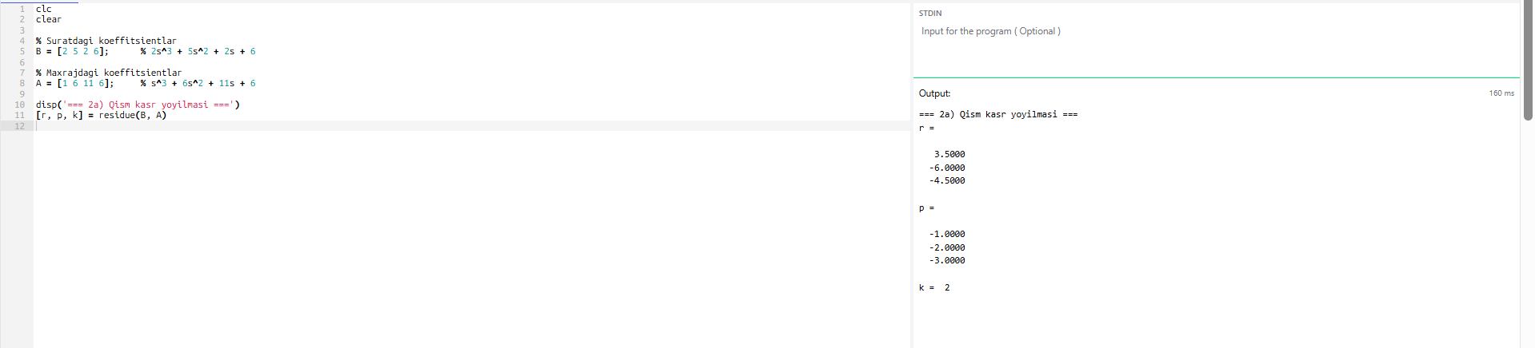

2b) B(s)/A(s) = (s²+2s+3) / (s+1)³
Avval (s+1)^3 ni kengaytiramiz, keyin residue() ni qo'llaymiz:

clc
clear

% Surat
B = [1 2 3]; % s^2 + 2s + 3

% Maxraj: (s+1)^3 = s^3 + 3s^2 + 3s + 1
A = conv(conv([1 1],[1 1]),[1 1])
disp('Maxraj koeffitsientlari (s+1)^3:')
disp(A)

disp('=== 2b) Qism kasr yoyilmasi ===')
[r, p, k] = residue(B, A)

Matematik ko'rinishi:
B(s)/A(s) = 1/(s+1) + (-1)/(s+1)² + 2/(s+1)³

Terminal Screenshot:
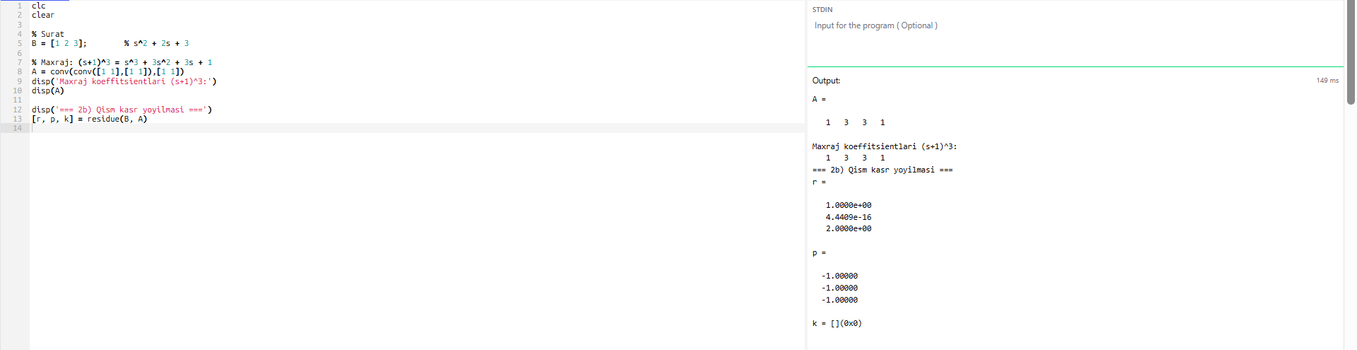

Xulosa
Ushbu amaliy ish davomida MATLAB da ko'pxadlar bilan ishlash o'rganildi:

- conv() — ko'pxadlarni ko'paytirish uchun ishlatildi (p(s) × q(s))
- roots() — ko'pxad ildizlarini topish uchun ishlatildi
- polyval() — ko'pxadni berilgan nuqtada hisoblash uchun ishlatildi
- residue() — qism kasrga yoyish uchun ishlatildi (2 xil holat)

Barcha topshiriqlar muvaffaqiyatli bajarildi va natijalar tekshirildi.

